Phil 3600: Philosophy of Religion  Spring 2025 | 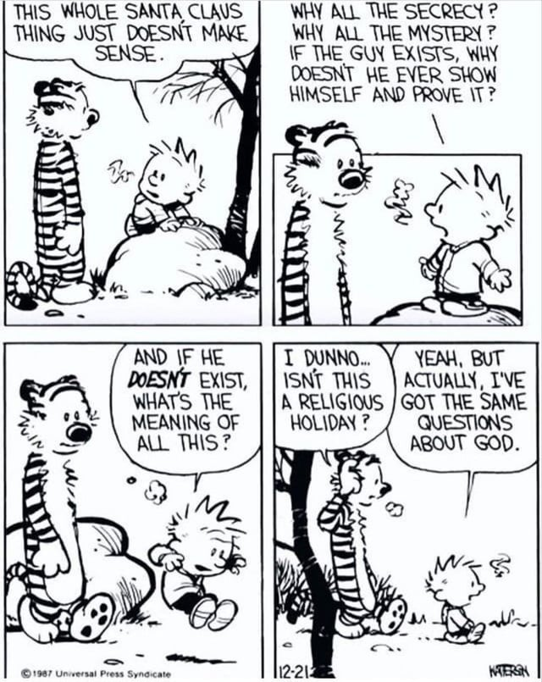
Jennifer Jensen, PhD
jjensen2@uccs.edu
Office: Columbine 4054
Office Hours: Mon/Wed 10:45am-11:45am
or By Appointment
Course Description
According to Anselm, God is the being “than which nothing greater can be thought.” In this course, we will be using philosophical argument to explore and evaluate this theistic conception of God. After a discussion of the role of reason in religious topics, we will focus the first half of our course on four traditional arguments for God’s existence. The second half of our course will focus on problems for theism including the problem of evil and various puzzles with the traditional divine attributes of omnipotence, omniscience, and omnibenevolence.

Course Objectives
Upon completion of the course, students will be able to:
- Describe and evaluate classical and contemporary philosophical literature in philosophy of religion
- Use basic philosophical methodology to analyze arguments in religious issues
- Clearly and precisely articulate philosophical positions on religious issues
- Profitably and charitably discuss controversial issues

Textbooks and Materials
Philosophy of Religion, 5th Edition. Michael Peterson, William Hasker, Bruce Reichenbach, David Basinger.
ISBN: 978-0-19-930344-1
HARD COPY REQUIRED
Other readings available on Canvas
A spiral notebook
A folder or 3 ring binder for articles and handouts

Course Requirements
Reading Annotations (20 points)
You will have a required reading assignment (of a reasonable length!) for (almost!) every day of class. While you are carefully reading the text, you will make annotations. You will submit a single pdf of your annotations on Canvas by the beginning of class on the day that the associated reading is due. Due to the fact that these are time-sensitive assignments, they will not be accepted late.
Over the course of the semester, there will be 23 reading annotation assignments. Each will be worth 1 point. I will drop your lowest three reading annotation grades. Thus, if you miss one or two or three readings, your reading annotations grade will not suffer. Note: On the days that you write a précise on your readings, you do NOT have to do reading annotations but you WILL receive full credit for reading annotations.

Précis (10 points each)
You will write two précis (concise summaries), each worth 10 points. In each précis, you will summarize the assigned reading of the day. At the end of the précis, you will ask a comprehension question or raise an objection. On the day your précis is due (we will sign up for dates), you will put your question/objection on the board. We will discuss this assignment in detail and sign up for dates on the second week of class.
Analysis Papers (30 points each)
You will write two analysis papers, each worth 30 points. The first will be due by 11:59 pm on March 19; the second will be due by 11:59 pm on May 7. In your analysis papers you will have the opportunity to engage in original and critical analysis of major themes, ideas, and concerns that we will discuss in the course.
The analysis papers will be 6-8 pages in length. We will peer review drafts of your first analysis paper in class on Monday, March 17th; the second will be peer reviewed on Monday, May 5th. Five points (a little more than 15%) of your analysis paper grade will be based on your draft and participation in these peer review sessions.
Late Penalty: For every day that your paper is late, you will lose 2 points.

Attendance
You are expected to attend every class session and be prepared to engage in the classroom discussion. You will not be permitted to attend class remotely. If you know that you have work, health, personal, or other reasons that will prevent you from attending class regularly, this is not the class for you. Having said that, I realize that you may sometimes miss class for reasons beyond your control. Therefore, there will be no penalty for the first four missed classes. Every absence beyond four will result in a 1.5 point reduction in your final grade. If you miss more than 10 classes, you will automatically receive an F in the course.

Class Policy
Technology in the Classroom:
The bulk of our class time will be spent in group discussion. This will require your active participation. To facilitate this, laptop computers, iPads, etc. will not be permitted in the classroom. Please plan to take your notes in a notebook. Moreover, I ask that you store your phone, headphones, and Air Pods in your backpack for the entirety of class.

Academic Honesty:
All written assignments are to be completed individually; students are in no way to work in a collaborative manner on papers unless explicitly given permission to do so. Any ideas that appear in your work that were obtained from an outside source must acknowledge that source. Note that academic dishonesty is a serious offense; any student caught plagiarizing parts or all of a paper or purchasing a paper from another source will receive an F in the course.

The use of AI tools, including Grammarly, is NOT permitted in this course unless explicit permission is given in the assignment. When the use of an AI tool is allowed, it will be explicitly noted in the assignment directions. You are responsible for the information you submit based on an AI query (for instance, that it does not violate intellectual property laws, or contain misinformation or unethical content). Your use of AI tools must be properly documented and cited, using quotation marks or other appropriate indicators of quoted material when appropriate, in order to stay within university policies on academic honesty.

Classroom Conduct:
Classroom disruptions negatively affect the learning environment. “Disruption,” as applied to the academic setting, means verbal and other behavior in the classroom that a faculty member judges as interfering with normal academic functions. Disruptive behavior will be handled according to the university policy. For more information, go to the UCCS Dean of Students webpage under the tab Student Conduct.

Schedule of Readings and Assignments

Date | Topic | Reading Assignment  *Reading is on Canvas | Submission Due
Wed.Jan.22 | Introduction | None | None
Mon.Jan.27 | Faith and Reason | Aquinas, “The Harmony of Reason and Revelation” (pp. 96-66) | RA 1
Wed.Jan.29 | Faith and Reason  DISCUSS PRÉCISE ASSIGNMENT  SIGN UP FOR PRÉCISES | Pascal, “The Wager” (pp. 100-101) | RA 2
Mon.Feb.3 | Faith and Reason | Clifford, “The Ethics of Belief” (pp. 103-107) | RA 3
Wed.Feb.5 | Faith and Reason | Plantinga, “The Reformed Objection to Natural Theology” (pp. 207-215) | RA 4
Mon.Feb.10 | Cosmological Argument | Aquinas, “The Five Ways” (Canvas—pp. 3-5) | RA 5
Wed.Feb.12 | Cosmological Argument | Rowe, “An Examination of the Cosmological Argument” (Canvas—pp. 15-24) | RA 6
Mon.Feb.17 | Cosmological Argument | Mackie, “Critique of the Cosmological Argument” (pp. 170-176) | RA 7
Wed.Feb.19 | Cosmological Argument | Craig, “The Kalam Cosmological Argument” (pp. 161-168) | RA 8
Mon.Feb.24 | Teleological Argument  The Analogical Version  DISCUSS ANALYSIS PAPER 1 | Paley, “The Analogical Teleological Argument” (pp. 177-179) | RA 9
Wed.Feb.26 | Teleological Argument  Critique of the Analogical Version | Hume, “Critique of the Analogical Teleological Argument” (pp. 180-186) | RA 10
Mon.Mar.3 | Teleological Argument  The Anthropic Version | Collins, “The Anthropic Teleological Argument”  (pp. 187-195) | RA 11
Wed.Mar.5 | Ontological Argument  The Classical Version | Anselm, “The Classical Ontological Argument” (pp. 133-134)  Gaunilo, “Critique of Anselm’s Argument” (pp. 135-137) | RA 12
Mon.Mar.10 | Ontological Argument  The Modal Version | Plantinga, “A Contemporary Modal Version of the Ontological Argument” (pp. 143-146) | RA 13
Wed.Mar.12 | Moral Argument | Lewis, “A Moral Argument for God’s Existence” (pp. 197-201) | RA 14
Mon.Mar.17 | Peer Review Session | No New Reading | Analysis Paper 1 Draft Due
Wed.Mar.19 | Writing Workshop | No New Reading | Analysis Paper 1 Due
Mon.Mar.24  Wed.Mar.26 | SPRING BREAK
Mon.Mar.31 | Problem of Evil  The Logical Problem of Evil | Mackie, “Evil and Omnipotence”  (pp. 329-337) | RA 15
Wed.Apr.2 | Problem of Evil  The Logical Problem of Evil | Plantinga, “The Free Will Defense” (pp. 346-356) | RA 16
Mon.Apr.7 | Problem of Evil  The Evidential Problem of Evil | Hick, “Soul-Making Theodicy”  (pp. 357-364) | RA 17
Wed.Apr.9 | Problem of Evil  The Evidential Problem of Evil | Rowe, “The Evidential Argument from Evil”  (pp. 365-373) | RA 18
Mon.Apr.14 | Omnipotence  If God is omnipotent, can God do absolutely everything?  DISCUSS ANALYSIS PAPER 2 | Aquinas, “God is Omnipotent”  (pp. 244-246) | RA 19
Wed.Apr.16 | Omnipotence  Continued | Geach, “Omnipotence” (Canvas—Just Read Theories 1-3, pp. 7-16) | RA 20
Mon.Apr.21 | Omnipotence  Can God make a stone so big that he cannot lift it? | Mavrodes, “Some Puzzles Concerning Omnipotence” (pp. 247-249) | RA 21  Analysis Paper 2 Article Due
Wed.Apr.23 | Omniscience  If God is omniscient, can human beings be free? | Pike, “Divine Omniscience and Voluntary Action” (pp. 250-254) | RA 22
Mon.Apr.28 | Omniscience  Continued | No New Reading | None
Wed.Apr.30 | Omnibenevolence  Must an all good God create the best possible world? | Adams, “Must God Create the Best”  (Canvas—Just Read Sections I-III, pp. 317-325) | RA 23
Mon.May.5 | Peer Review Session |  | Analysis Paper 2 Draft Due
Wed.May.7 | Writing Workshop |  | Analysis Paper 2 Due

