Phil 3350  The Nature of Things:  Metaphysics | 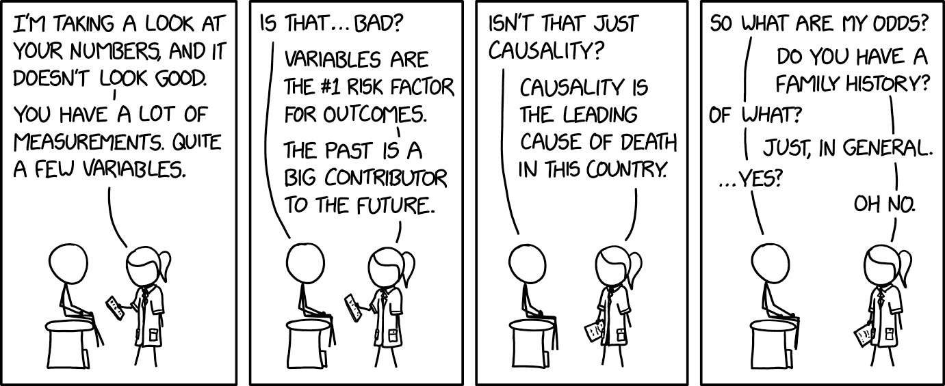
Jennifer Jensen, PhD
jjensen2@uccs.edu
Office: Columbine 4054
Office Hours: Tues/Thurs 1:30pm – 2:30pm
or By Appointment

Course Description
The way things appear is not always the way things are in reality. It appears that the sun rises in the east, travels across the sky, and sets in the west. But we know that this is not really the case. Metaphysics is the study of the nature of things. It attempts to get beyond appearances and discover the way things really are. What things? Everything! So there are many different entry points into the study of metaphysics. In this class, we will begin with a speed run through metaphysics to develop a sense for the discipline and build our metaphysical vocabulary. Then we will think hard about identity through time. Can a physical object survive change? Does it persist through time? If so, in virtue of what does it persist through time? And do YOU persist through time? How? Finally, we will consider causation and the perennial question of free will. What does it mean for one event to cause another? And do YOU cause events? Do you do so freely?
Grading Scale
A = 93 points or more
A- = 90-92 points
B+ = 88-89 points
B = 83-87 points
B- = 80-82 points
C+ = 78-79 points
C = 73-77 points
C- = 70-72 points
D+ = 68-69 points
D = 63-67 points
D- = 60-62 points
F = 59 points or less

Course Objectives
Upon completion of the course, students will be able to:
- Describe and evaluate contemporary philosophical literature in metaphysics
- Use basic philosophical methodology to analyze arguments in metaphysics
- Clearly and precisely articulate philosophical positions on issues in metaphysics
- Profitably and charitably discuss controversial issues

Textbooks and Materials
Metaphysics: The Big Questions (2nd Edition), 2008. Peter van Inwagen and Dean Zimmerman.
ISBN: 978-1-4051-2586-4
Metaphysics: A Very Short Introduction, 2012. Stephen Mumford.
ISBN: 978-0-19-965712-4
A Dialogue on Personal Identity and Immortality, 1978. John Perry.
Basis for Grading

Reading Annotations = 20 points
Precise 1 = 10 points
Precise 2 = 10 points
Analysis Paper 1 = 30 points
Analysis Paper 2 = 30 points

ISBN: 0-915144-53-0
Other readings available on Canvas
A spiral notebook

Course Requirements
Reading Annotations (20 points)
You will have a required reading assignment (of a reasonable length!) for (almost!) every day of class. While you are carefully reading the text, you will make annotations. You will submit a single pdf of your annotations on Canvas by the beginning of class on the day that the associated reading is due. Due to the fact that these are time-sensitive assignments, they will not be accepted late.
Over the course of the semester, there will be 23 reading annotation assignments. Each will be worth 1 point. I will drop your lowest three reading annotation grades. Thus, if you miss one or two or three weeks, your reading annotations grade will not suffer. Note: On the days that you write a précise on your readings, you do NOT have to do reading annotations but you WILL receive full credit for reading annotations.

Précis (10 points each)
You will write two précis (concise summaries), each worth 10 points. In each précis, you will summarize the assigned reading of the day. At the end of the précis, you will ask a comprehension question or raise an objection. On the day your précis is due (we will sign up for dates), you will put your question/objection on the board. We will discuss this assignment in detail and sign up for dates on the second week of class.

Analysis Papers (30 points each)
You will write two analysis papers, each worth 30 points. The first will be due by 11:59 pm on Sunday, October 19; the second will be due by 11:59 pm on Thursday, December 11. In your analysis papers you will have the opportunity to engage in original and critical analysis of major themes, ideas, and concerns that we will discuss in the course.
The analysis papers will be 6-8 pages in length. We will peer review drafts of your first analysis paper in class on Thursday, October 16; the second will be peer reviewed on Tuesday, December 9. Five points (a little more than 15%) of your analysis paper grades will be based on your draft and participation in these peer review sessions.
Late Penalty: For every day that your paper is late, you will lose 2 points.

Attendance
You are expected to attend every class session and be prepared to engage in the classroom discussion. You will not be permitted to attend class remotely. If you know that you have work, health, personal or other reasons that will prevent you from attending class regularly, this is probably not the class for you. Having said that, I realize that you may sometimes miss class for reasons beyond your control. Therefore, there will be no penalty for the first four missed classes. Every absence beyond four will result in a 1.5 point reduction in your final grade. If you miss more than 10 classes, you will automatically receive an F in the course.

Class Policy
Technology in the Classroom:
The bulk of our class time will be spent in group discussion. This will require your active participation. To facilitate this, laptop computers, iPads, etc. will not be permitted in the classroom. Please plan to take your notes in a notebook. Moreover, I ask that you store your phone, headphones, and AirPods while in the classroom.

Academic Honesty:
All written assignments are to be completed individually; students are in no way to work in a collaborative manner on papers unless explicitly given permission to do so. Any ideas that appear in your work that were obtained from an outside source must acknowledge that source. Note that academic dishonesty is a serious offense; any student caught plagiarizing parts or all of a paper or purchasing a paper from another source will receive an F in the course.

The use of AI tools, including Grammarly, is NOT permitted in this course unless explicit permission is given in the assignment. When the use of an AI tool is allowed, it will be explicitly noted in the assignment directions and the acceptable use of such tools will also be detailed. You are responsible for the information you submit based on an AI query (for instance, that it does not violate intellectual property laws, or contain misinformation or unethical content). Your use of AI tools must be properly documented and cited, using quotation marks or other appropriate indicators of quoted material when appropriate, to stay within university policies on academic honesty.

Classroom Conduct: Classroom disruptions negatively affect the learning environment. “Disruption,” as applied to the academic setting, means verbal and other behavior in the classroom that a faculty member judges as interfering with normal academic functions. Disruptive behavior will be handled according to the university policy. For more information, go to the UCCS Dean of Students webpage under the tab Student Conduct.

Schedule of Readings and Assignments

Date | Topic | Reading Assignment  *Reading is on Canvas | Submission Due
Tues.Aug.26 | Introduction | None | None
Thurs.Aug.28 | Metaphysics: The Big Picture  Medium Sized Objects and their Features | Mumford, Chapters 1-3 | RA 1
Tues.Sept.2 | Metaphysics: The Big Picture  Changes and Causes  DISCUSS PRÉCISE ASSIGNMENT  SIGN UP FOR PRÉCISES | Mumford, Chapters 4-5 | RA 2
Thurs.Sept.4 | On Metaphysics: The Big Picture  Finish Up Causes (Ch. 5)  Time | Mumford, Chapter 6 | RA 3
Tues.Sept.9 | Metaphysics: The Big Picture  Persons | Mumford, Chapter 7 | RA 4
Thurs.Sept.11 | Metaphysics: The Big Picture  Possibility, Nothingness, and Metaphysics | Mumford, Chapter 8-10 (Chapter 9 is optional) | RA 5
Tues.Sept.16 | Change  Endurantism | *Chisholm, “Identity Through Time” | RA 6
Thurs.Sept.18 | Change  Perdurantism | Quine, “Identity, Ostension, and Hypostasis”  (Big ?s: pp. 263-265) | RA 7
Tues.Sept.23 | Change  Perdurantism | Lewis, “The Problem of Temporary Intrinsics” (Big ?s: pp. 267-269) | RA 8
Thurs.Sept.25 | Personal Identity  Introduction  DISCUSS ANALYSIS PAPER 1 | No New Reading | None
Tues.Sept.30 | Personal Identity  The Soul | Perry, “The First Night” | RA 9
Thurs.Oct.2 | Personal Identity  The Body | Perry, “The Second Night” | RA 10
Tues.Oct.7 | Personal Identity  Person Stages | Lewis, “In Defense of Stages: Postscript B to ‘Survival and Identity’”  (Big ?s: pp. 265-267) | RA 11
Thurs.Oct.9 | Personal Identity  The Transplant Case | Perry, “The Third Night” | RA 12

Tues.Oct.14 | Personal Identity  The Buddhist No Self Doctrine | *Anonymous, “The Buddhist View of Rebirth” | RA 13
Thurs.Oct.16 | Peer Review Session | No New Reading | Analysis Paper 1 Draft Due
Sun.Oct.19 |  |  | Analysis Paper 1 Due at 11:59pm
Tues.Oct.21 | Causation  Introduction | No New Reading
Thurs.Oct.23 | Causation  Hume on Constant Conjunction | Hume, “Constant Conjunction: An Excerpt from A Treatise of Human Nature”  (Big ?s: pp. 285-289) | RA 14
Tues.Oct.28 | Causation  Counterfactuals | *Lewis, “Causation” | RA 15
Thurs.Oct.30 | Causation  The INUS Condition | *Mackie, “Causes and Conditions” (Read Only Section 1-Singular Causal Statements) | RA 16
Tues.Nov.4 | Causation  Non-Necessary Causation | Anscombe, “Causality and Determination”  (Big ?s: pp. 306-320—Focus on Section I; skim Section II) | RA 17
Thurs.Nov.6 | Free Will  Determinism  DISCUSS ANALYSIS PAPER 2 | d’Holbach, “We are Never Free”  (Big ?s: pp.413-419) | RA 18
Tues.Nov.11 | Free Will  Libertarianism | van Inwagen, “The Mystery of Metaphysical Freedom”  (Big ?s: pp. 456-465) | RA 19
Thurs.Nov.13 | Free Will  Libertarianism | Chisholm, “Human Freedom and the Self”  (Big ?s: pp. 441-450) | RA 20  Analysis Paper 2 Article Due
Tues.Nov.18 | Free Will  Agent Causation | O’Connor, “The Agent as Cause”  (Big ?s: pp. 465-471) | RA 21
Thurs.Nov.20 | Free Will  Compatibilism | *Beebee, “Compatibilism and the Ability to Do Otherwise” (Skim the beginning, focus on pp. 515-520) | RA 22
Tues.Nov.25  Thurs.Nov.27 | FALL BREAK | No New Reading
Tues.Dec.2 | Free Will  Free Will and Moral Responsibility | Frankfurt, “Alternate Possibilities and Moral Responsibility”  (Big ?s: pp. 471-479) | RA 23
Thurs.Dec.4 | Catch Up/Snow Day | No New Reading
Tues.Dec.9 | Peer Review Session |  | Analysis Paper 2 Draft Due
Thurs.Dec.11 | Writing Workshop |  | Analysis Paper 2 Due at 11:59pm

